**GOVERNMENT ARTS AND SCIENCE COLLEGE (CO-ED)**

**SANKARANKOVIL**

**TENKASI - DISTRICT**

**Machine learning with python**

**April-2023**

***The Future of University Decision Making with Machine Learning***

***Team Size: 4***

TEAM LEADER **: VIJI.K**

REG NO **:(20201361506132)**

TEAM MEMBER 1 **: BHUNANESWARI. V**

REGNO **:(20201361506105)**

TEAM MEMBER 2 **: GOWSALIYA. V**

REGNO**:(20201361506107)**

TEAM MEMBER3**: KAVUSALYA. S**

REGNO**:(20201361506108)**

***Table of contents:***

|  |  |  |  |  |  |  |  |  |  |  |  |  |  |  |  |  |  |  |  |  |  |  |  |  |  |  |  |
| --- | --- | --- | --- | --- | --- | --- | --- | --- | --- | --- | --- | --- | --- | --- | --- | --- | --- | --- | --- | --- | --- | --- | --- | --- | --- | --- | --- |
| |  |  |  | | --- | --- | --- | | **SNO** | **CONTENTS** | **PAGE NO** | | **1.** | **Introduction** | **4** | | **2.** | **PROBLEM DEFINTION & DESIGN THINKING** | **9** | | **3.** | **RESULT** | **10** | | **4.** | **ADVANTAGES & DISADVANTAGES** | **13** | | **5.** | **APPLICATIONS** | **15** | | **6.** | **CONCLUSION** | **16** | | **7.** | **FUTURE SCOPE** | **18** | | **8.** | **APPENDIX** | **19** | |

***INTRODUCTION:***

* University admission or college admission is the process through which students enter tertiary education at universities and colleges. Systems vary widely from country to country, and sometimes from institution to institution.
* In many countries, prospective university students apply for admission during their last year of high school or community college. In some countries, there are independent organizations or government agencies to centralize the administration of standardized admission exams and the processing of applications .Acceptance to a Canadian university or college often requires completion of a high school diploma (or equivalent). Some colleges or universities accept applicants based on other outcomes, such as the General Educational Development test, age and life experience, admissions testing, or other criteria.
* In Canada, the difference between college and university is significantly different from the typical interpretation in the United States or even United Kingdom. A Canadian college is more similar to an American community college[citation needed]. In contrast, a Canadian university is comparable to an American university, and virtually all Canadian universities have endowments over $20 million, most frequently above $100 million. Almost all Canadian post-secondary institutions are publicly funded (thatis,government subsidized). The few private institutions that are not government-supported are not widely known at all, have generally only been established since the 1980s, and are mostly located in British Columbia.
* In the Canadian education system, which varies from province to province, colleges are geared for individuals seeking more specific technical careers, such as graphic design or animation whereas universities are geared to individuals seeking more academic careers where a university degree is a prerequisite for entrance, such as medicine or law. There are other systems in place for students to enter traditional trades (called "skilled trades" in Canada), and some provinces have unique preparatory systems or schools, such as Quebec's pre-university college level.

***Overview:***

* You’re ready to take a deep dive into the subjects you are most passionate about. Ready to prepare for professional life, boost your career, push yourself to new frontiers of knowledge. In short, you’re ready to take on the challenge of graduate school. Looking for a program? Ready to apply? Curious about funding? You’re in the right place.
* At Boston University, you’ll find nearly 400 graduate programs, where opportunities for collaborative learning abound. You’ll find three campuses, all in Boston, a thriving city that is rich with history yet firmly future-facing. You willfind on-campus and online programs, full-time and part-time, master’s, doctoral, and professional degrees. You’ll find an academic community comprised of great minds from all over theglobe, united in a shared mission of learning and advancement.
* We also recommend that you use our Program Finder tool to find the right program for you, or find information about funding your degree. When you’re ready to apply, check out our Graduate Admission page, which links you to individual school and college admissions pages.
* In the UK prospective students apply for university places through the UCAS administrative system. Students applying through UCAS are required to submit various types of information including: predicted exam grades, a personal statement and academic references. Universities assess the information provided by candidates and offer students places based on a holistic assessment of all the data provided.
* The university admissions system has been under scrutiny for decades and reviews have been conducted such as the Schwartz Review in 2004. Tweaks have been made to the system as a result of these reviews, but a number of criticisms remain. Current concerns are focused on the use of

ensure predicted grades and unconditional offers and in particular on their impact on disadvantaged students.

* The minority of university offers are unconditional, but the share of all offers made that were recorded as unconditional has increased significantly, from 9.2 per cent in 2013, to 15.1 per cent in 2018. Most unconditional offers are made to older students, but the unconditional offer rate for 18 year olds has driven the overall increase in unconditional offers. In 2013 1.1% of 18 year old applicants received at least one unconditional offer, by 2019 this had increased to 37.7%.
* Unconditional offers are more common at universities with lower entry requirements. In 2013 just 16 universities had unconditional offer rates to 18 year olds of 1% or more. In 2019 this number had increased to 88.We provide exceptional service to direct and agency-supported students interested in studying in the United States, Canada and other countries. From our headquarters in New York, the University Study network of counselors and agency partners serve thousands of students each year.
* Students around the world rely on University Study to assist them with bachelor’s, master’s, doctoral, secondary school, short-term Study Abroad, English language, and pathway programs. We communicate daily with students, their families, and representative agencies to match student interest with the best possible institutions. University Study has partnered with an exceptional group of high schools and universities who are interested in attracting international students. All of our partner schools provide quality service to University Study applicants to that admission decisions and I-20's are issued promptly. Students working with us are afforded a wide variety of opportunities to secure academic, athletic and talent based scholarships.
* Our university partners offer excellent, accredited academic programs; ensuring the highest standard of service is provided. University Study works closely with its agency partners to be sure that its policies and principles of conduct are consistent with the National Association of Foreign Student Advisors (NAFSA) Statement of Ethical Principles as well as complying with the American International Recruitment Council (AIRC) policies of best practice.
* We provide exceptional service to direct and agency-supported students interested in studying in the United States, Canada and other countries. From our headquarters in New York, the University Study network of counsellors and agency partners serve thousands of students each year.
* Students around the world rely on University Study to assist them with bachelor’s, master’s, doctoral, secondary school, short-term Study Abroad, English language, and pathway programs. We communicate daily with students, their families, and representative agencies to match student interest with the best possible institutions. University Study has partnered with an exceptional group of high schools and universities who are interested in attracting international students. All of our partner schools provide quality service to University Study applicants to ensure that admission decisions and I-20's are issued promptly. Students working with us are afforded a wide variety of opportunities to secure academic, athletic and talent based scholarships.
* Our university partners offer excellent, accredited academic programs; ensuring the highest standard of service is provided. University Study works closely with its agency partners to be sure that its policies and principles of conduct are consistent with the National Association of Foreign Student Advisors (NAFSA) Statement of Ethical Principles as well as complying with the American International Recruitment Council (AIRC) policies of best practice.

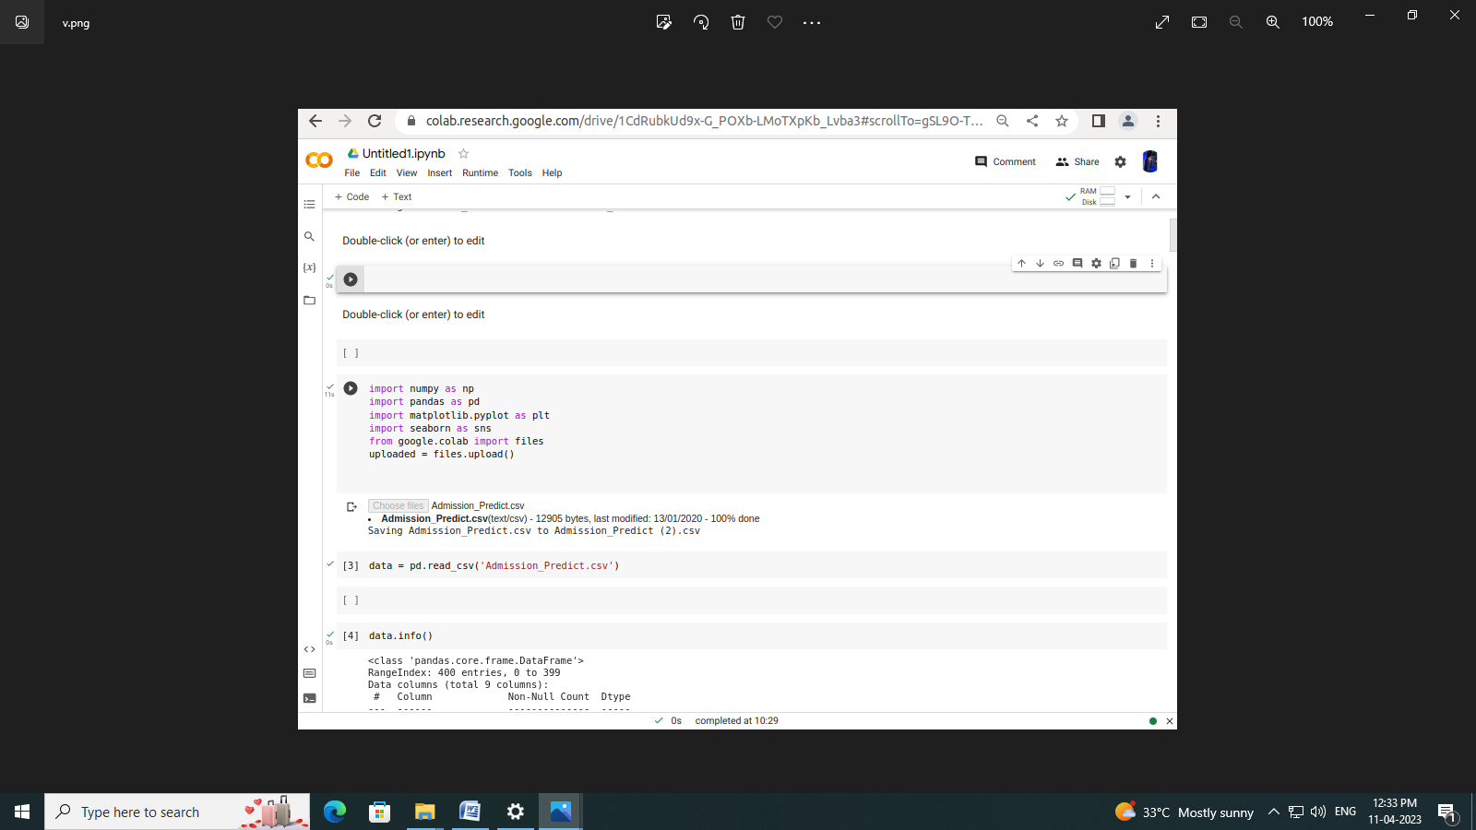

***Problem definition:***

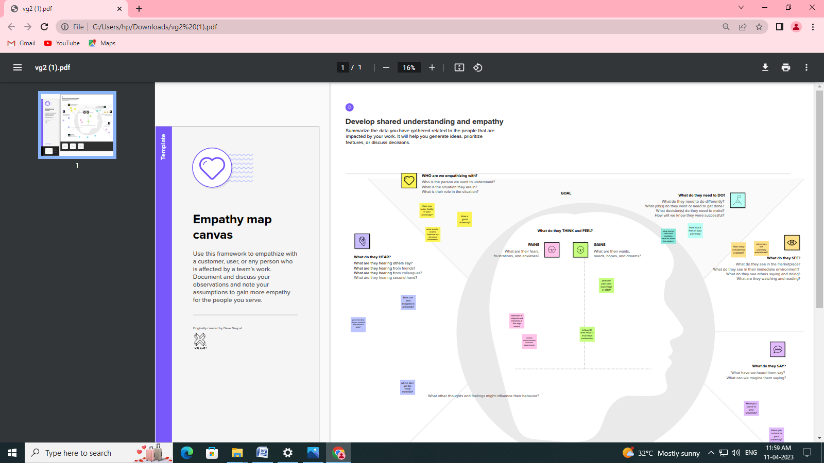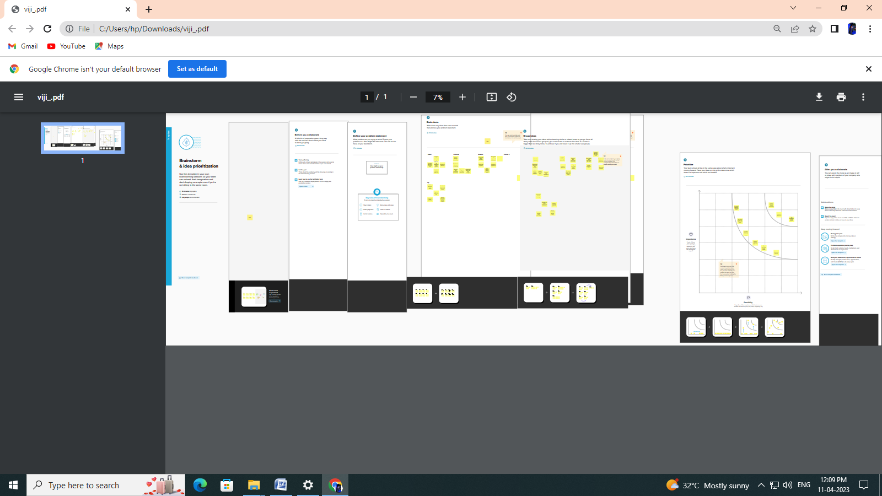

***Result:***

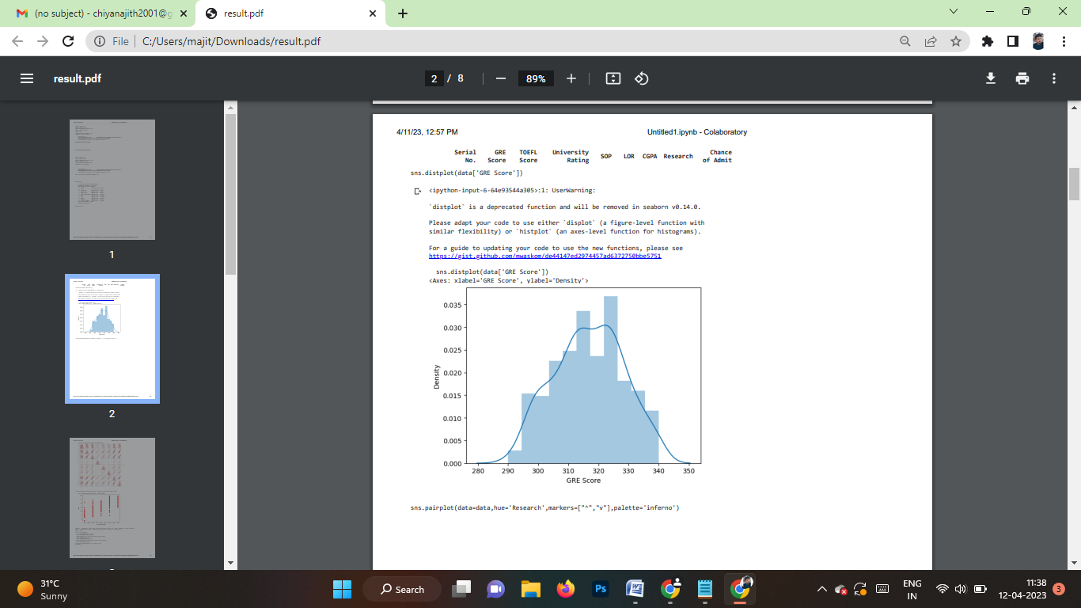

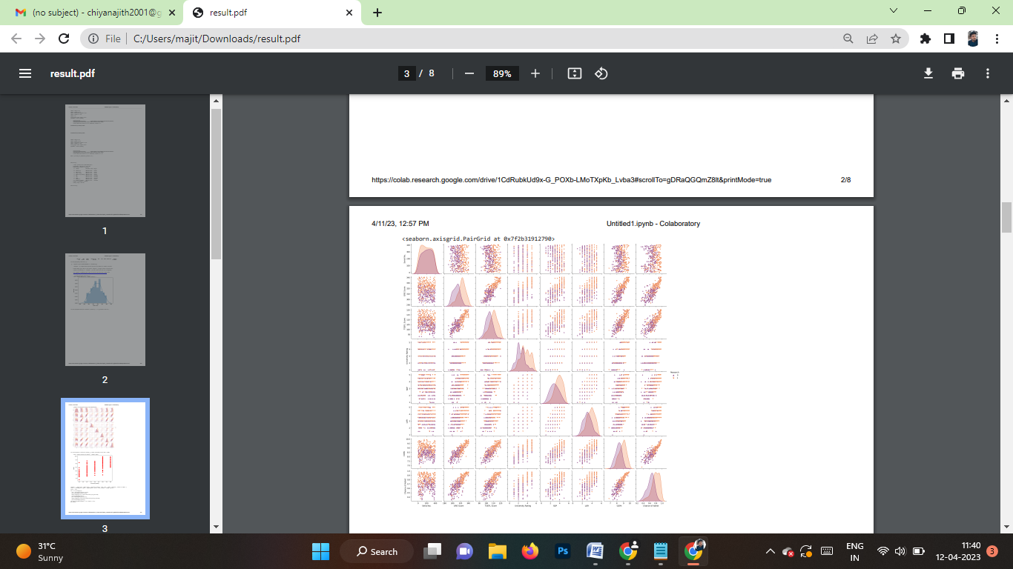

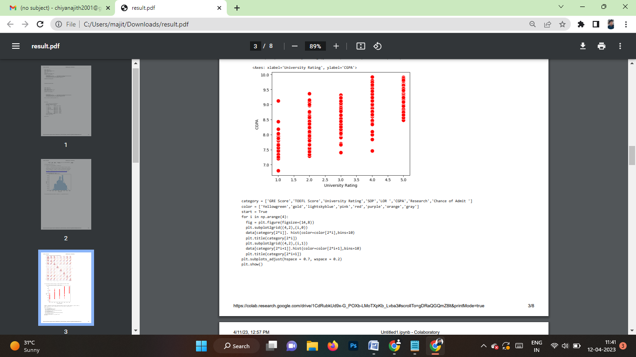

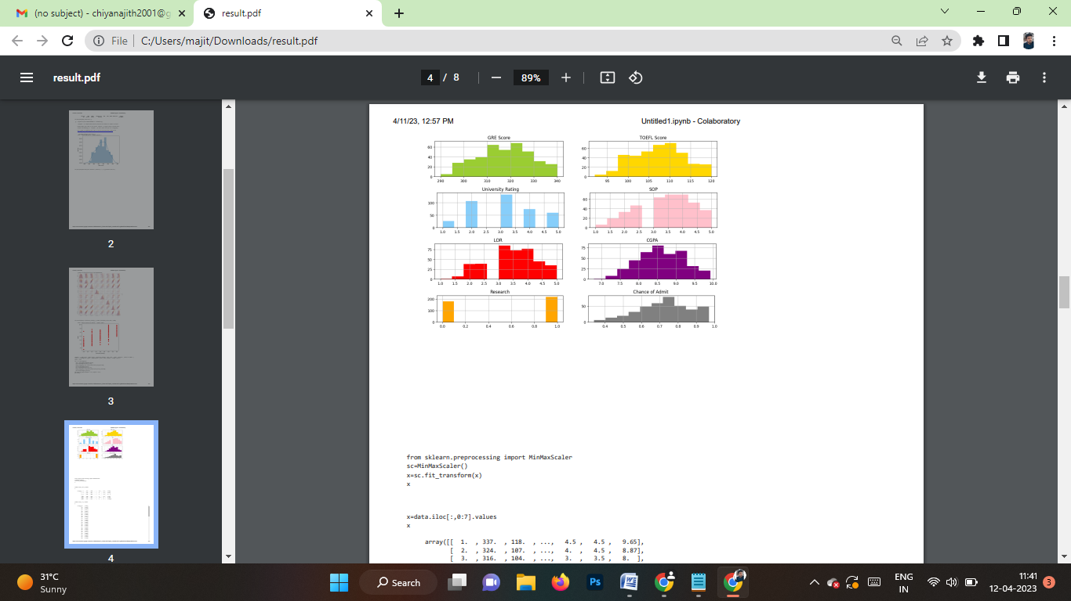

***Adavantage & Disadvantage:***

Advantages of Online Admission

* Applicants’ Convenience – One of the greatest advantages of the online application system is that applicants can choose to submit their applications at their convenience.
* All that is required is access to a computer and internet connectivity.
* This is a great advantage to candidates in rural areas and candidates with disabilities.
* Logistics – No more running out of paper application forms, picking the right colour ink pens, illegible prints and wondering if the application has been received at all. The online application process offers university applicants a uniform platform for filling in their applications and also provides prompts on which fields are mandatory. The acknowledgement is almost immediate and the system user-friendly. This is a great advantage to candidates in rural areas and candidates with disabilities.
* Advantage to Universities – Universities and educational institutions are also at a major advantage when it comes to an online admission process. Quick access to student records and databases, efficient systems for filtering out candidates and processing of applications is possible through the online application process. The costs of processing applications and employing additional manpower during admissions are slashed with the implementation of an online application system.
* Increases Accuracy and Efficiency – Those who have seen university officials accepting thousands of paper applications each day at office counters understand that high fatigue and monotony involved in the paperwork is a catalyst for errors. Each error could cost students their academic career and educational prospects.
* The online admission system is highly reliable and efficient and eliminates chances of such errors.
* Demolishing Geography – Another great advantage of the online admission systemisthat it makes it possible for candidates from across the country and even abroad to apply to Indian universities without any hassles. It eliminates the inconveniences caused by ailments and exigencies, providing deserving candidates a convenience that has never before been available.

**Disadvantages of Online Admission**

* Computer Literacy and Internet Access – In India, though Internet penetration is rather high, Internet connectivity and speed issues are major impediments to bring any real advantage to university applicants. Most rural areas experience high blackouts and electricity issues. This means, once again candidates in urban districts and areas are placed at a significant advantage.
* Low Computer Literacy – Another major concern is the low rate of computer literacy in India. Current estimates say that only about 6.5 percent Indians are computer savvy. A sudden shift to the online admission process is likely to cause confusion and despondency among a great many applicants.
* Security Concerns – In a country like India where security fails of online systems have become increasingly common over the years, online applications make it easier for systems to be breached and for applications or scores to be manipulated. The fear that hackers may target universities and educational institutions is a grave one. Unintentional system failures or server crashes may disrupt the entire admission process of universities and educational institutions. Another important concern is the confidentiality of student information and associated security risks involved in online application processing.
* Authenticity – In most manual admission processes, the eligibility of candidates is proved by verification of originals at the time of accepting applications, ensuring that only genuine candidates apply. Online applications make it easier for fraudsters to manipulate the application process and eligibility requirements.
* Infrastructural Requirements – Building a robust and secure online admission process is a task that requires financial and infrastructural resources. Many universities and educational institutions may not have the necessary resources and all these costs will ultimately be borne by the students. In a country where higher education is a luxury few can afford, increased costs may be a deterrent for education.

***Application:***

* The primary application of university admissions is to allow students to apply for admission to a higher education institution. The admission process typically involves submitting an application, including academic records, standardized test scores, essays, and letters of recommendation. The university then evaluates the application and decides whether to offer the student admission.

**There are several reasons why university admissions are important**:

* Education: University online admissions allow students to pursue higher education and gain knowledge and skills that can help them in their careers.
* Career opportunities: Many employers require a college degree for certain positions, so university admissions can open up new job opportunities for students.
* Personal development: University admissions provide students with opportunities to develop new interests, hobbies, and skills, which can enrich their lives and help them become more well-rounded individuals.
* Research: University admissions can also contribute to scientific research and knowledge generation. Universities are often at the forefront of cutting-edge research in a wide range of fields, and students can contribute to this research through their academic work.
* Innovation: University admissions can also lead to new innovations in technology, medicine, and other fields. Many groundbreaking innovations have emerged from university research and collaboration between students, faculty, and industry partners.
* Overall, university admissions play a critical role in society by providing students with opportunities to gain knowledge, develop new skills, and contribute to research and innovation.

***Conclusion:***

* Your essay is one of the most essential parts of your college application. It's your chance to tell your story, using your unique voice to showcase your personality, achievements, and goals. And arguably, the ending of your essay is the most important part of it all. It's your last chance to make an impact and leave a lasting impression on the reader.
* In this article, we’ll look at some do's and don’ts for ending your essay and give you five simple but effective techniques you can use to wrap things up. All right, enough chatter. On to the good stuff.Finding a conclusion for your college essay is one of the most challenging parts of writing it.
* Once you have written the introduction and the body paragraphs of the essay, you might feel like you’ve said everything you intended to say. You might wonder what else is left.
* There is risk in not concluding your essay well.
* Your conclusion is likely the last thing an admissions officer is going to read.
* It’s your final handshake with the reader.
* It’s your exit through the door. The impression you leave in the final sentences of your essay will remain with your reader.
* A great conclusion can be more powerful than anything featured on your transcript because it can set you apart from everyone else.

Here are tips for what to avoid, and what to do, in order to write the best conclusion for your college essay.

***Future scope:***

**1**. Website and online portal for admission should be prepared well in advance and

Ready portal should be demonstrated to the Admission Committee of the college

Before final selection of the service provider. After the section of the service provider

selected party must present a trial run to the Admission Committee before the

commencement of receiving online applications.

**2**. An applicant should be able to fill up the form directly without any login.

The information technology industry is growing at a very fast pace. Every sector is adopting new and superior technologies to carry out tiresome tasks to optimise efficiency. The high demand for IT professionals in today’s world has made courses offered in this field really popular among masses. Bachelor of Science in Information Technology is one such course that equips students with knowledge of storage processing, securing, and maintaining databases and exposure to information processing. But before you sign up for the course, it is essential to know about the different career pathways you can explore. Here is an insightful blog on focusing on the its scope.

***Appendix:***

import numpy as np

import pandas as pd

import matplotlib.pyplot as pd

import seaborn as sns

import csv

from google.colab import files

uploaded = files.upload()

Double-click (or enter) to edit

Double-click (or enter) to edit

Choose Files No file chosen Upload widget is only available when the cell has been

executed in the current browser session. Please rerun this cell to enable.

Saving Admission Predict csv to Admission Predict (2) csv

import numpy as np

import pandas as pd

import matplotlib.pyplot as plt

import seaborn as sns

from google.colab import files

uploaded = files.upload()

data = pd.read_csv('Admission_Predict.csv')

data.info()

<class 'pandas.core.frame.DataFrame'>

RangeIndex: 400 entries, 0 to 399

Data columns (total 9 columns):

# Column Non-Null Count Dtype

--- ------ -------------- -----

0 Serial No. 400 non-null int64

1 GRE Score 400 non-null int64

2 TOEFL Score 400 non-null int64

3 University Rating 400 non-null int64

4 SOP 400 non-null float64

5 LOR 400 non-null float64

6 CGPA 400 non-null float64

7 Research 400 non-null int64

8 Chance of Admit 400 non-null float64

dtypes: float64(4), int64(5)

memory usage: 28.2 KB

data.isnull()

4/11/23, 12:57 PM Untitled1.ipynb - Colaboratory

https://colab.research.google.com/drive/1CdRubkUd9x-G_POXb-LMoTXpKb_Lvba3#scrollTo=gDRaQGQmZ8lt&printMode=true 2/8

Serial

No.

GRE

Score

TOEFL

Score

University

Rating SOP LOR CGPA Research Chance

of Admit

0 False False False False False False False False False

1 False False False False False False False False False

2 False False False False False False False False False

3 False False False False False False False False False

4 False False False False False False False False False

... ... ... ... ... ... ... ... ... ...

395 False False False False False False False False False

396 False False False False False False False False False

397 False False False False False False False False False

398 False False False False False False False False False

399 False False False False False False False False False

400 rows × 9 columns

<ipython-input-6-64e93544a305>:1: UserWarning:

`distplot` is a deprecated function and will be removed in seaborn v0.14.0.

Please adapt your code to use either `displot` (a figure-level function with

similar flexibility) or `histplot` (an axes-level function for histograms).

For a guide to updating your code to use the new functions, please see

https://gist.github.com/mwaskom/de44147ed2974457ad6372750bbe5751

sns.distplot(data['GRE Score'])

<Axes: xlabel='GRE Score', ylabel='Density'>

sns.distplot(data['GRE Score'])

sns.pairplot(data=data,hue='Research',markers=["^","v"],palette='inferno')